**CONSUMER PSYCHOLOGY**

**ABSTRACT**

This study demonstrates the concept of consumer psychology that is applied practically on consumer behaviour. It is essential knowing the consumer psychological aspects to understand consumer behaviour towards buying decision. Assessing psychological theories have been initiated to know how it links to consumer behaviours. The practical application of consumer psychology has been found in consumer behaviour that have been a key research areas by the academicians and marketers. It requires to have in depth understanding of consumer emotion and marketers develop stimuli accordingly to persuade them. The impact of society on consumer decision making process need to be understood in all the phases as consumer emotion and perception towards a product or brand remains key towards such marketing study. Consumer psychological model of brands indicate various layers of consumer decision that impacts on consumer behaviour towards brand selection and it is essential for marketers towards consumer persuasion. This study concludes by highlighting the impact of consumer behaviour or attributes on consumer decision making process to select a brand or product.

**ASSESSING PSYCHOLOGICAL THEORIES IN CONSUMER BEHAVIOUR**

Shavitt et al. (2008) has described that consumer psychology is about studying human responses towards a particular product or service oriented information as well as experiences. Several responses remain relevant that includes emotional, cognitive (views as well as judgments), as well as behavioural (buying decisions as well as consumption-oriented practices) replies. Psychological theories denotes how consumer take decision of buying and how such relevant information is significant that marketer initiate to create stimuli (such as package labels, advertisements, coupons, displays of point-of-purchase etc.), word-of mouth communications from family and friends, consumer magazines. Any response towards information regarding a products may be impacted by three key psychological factors: a) person variables (such as prior attitudes, opinions and personality variables), b) situational variables (such as stimuli initiated by the marketer, product variables), as well as c) individual by situation interactions. Such goal of consumer psychologists remain describing, predicting, influencing, as well as explaining consumer responses towards product as well as service oriented information.

Loken (2008) has argued that consumer psychology is impacted by the culture, which is shapes consumer behaviour. However, despite understanding fundamental role of consumer psychology, comparatively limited research have been found in this topic, consumer behaviour as well as marketing has observed the interface of culture in consumer psychology as well as consumer behaviour. The existing theories in marketing that has combined research data in this regards except United States has been found very narrow. Many reasons are there that lacks investigation towards cultural aspect into psychology and consumer behaviour perspective. Such reasons starts from practical difficulties to an ethnocentric trust that such psychological values i.e. consumer emotion are world-wide. The main objective towards such special issue remains examining certain issues as well as provide certain guidelines in facilitating academic review in the cultural domain.

**PRACTICAL APPLICATION OF CONSUMER PSYCHOLOGY**

Schumann et al. (2008) has stated that the area of consumer psychology started from as well as has sustained towards developing as per the scientific revision of human psychology. Such literatures have pointed a rather uneasy rigidity between logical study in the aspect of consumer psychology, as well as practical application of such understanding towards consumer behaviour domain. During 1950 there have been arguments among consumer psychology practitioners as well as academics functioning in the area of consumer psychology.

According to Bayus (2010) consumer psychology is applied in understanding consumer behaviour, as well as industrial buyer behaviour. Consumer behaviour is studied by the marketers from the time before marketing domain itself turned into academic subject. Such academic topic that led to marketing comprised economics (understanding supply and demand), sociology (group behaviour), psychology (study related to thought procedures). Presently, the fundamental theory of marketing remains associated with customer centrality which should not be ignored because customer decision-making process is involved. Knowing the associated factors to make those consumer decision making process remains vital the needs understanding consumer psychology. Knowledge of consumer psychology and subsequently consumer behaviour is highly beneficial to apply on brand attachment strategies by the marketers to promote their brands. Consumer engagement is essential towards brand attachment looks like essential towards constructing such expresses towards connection of the consumer with such brand.

**IMPACT OF CONSUMER SOCIETY ON THE PSYCHOLOGICAL PROCESS AND FUNCTIONING OF INDIVIDUALS**

Consumer emotion is an aspect that is highly influenced by culture and it develops a psychological perspective to a great extent. A consumer society may have various sub- cultures where people may identify. Such Subcultures in a society are the sub groups consist of people those share similar values depending on a collective experience or generally alike lifestyle that impact psychological process and behaviour of individuals. The study of Isen (2008) has indicated that such possible impact of emotions on consumer decision making process exist to buy or choose a brand. Isen argued that the positive impact can be constantly perceived to get a positive effect on cognitive processes, behaviour and decision-making. Society and culture remains crucial when it is required understanding such needs as well as behaviours of an individual. Mainly, culture remains a segment of each society as well as remains key reasons of wants and behaviour of the persons. Such impact of society on consumer buying behaviours differs from country to country, thus marketers need to do careful analysis of culture before adopting advertisement strategy. They should study culture and society to understand consumer behaviour. Society generally would teach values, common behaviours as well as preferences to their individual culture. It is necessary for a marketer or a brand to understand such societal aspect and emotion that influence individuals to function accordingly. Advertisement must consider various cultural aspects integral to every market or to every situation towards adapting its product as well as its marketing strategy since it plays a significant role towards consumer habits, perception behaviour, expectations and any emotional bond.

Consumer behaviour indicates that such buying behaviour is the ultimate consideration. Several aspects, specificities as well as features impact an individual the way such consumers develop their process of decision making, shopping habits, buying behaviour, selection of any brand or choosing a retailer. Consumer buying decision remains an outcome of every such factors since consumers are led by subculture, social class, membership groups, family, personality, psychological factors, etc. (Woodside et al., 2008).

**METHODS OF UNDERSTANDING CONSUMER PSYCHOLOGY TO INVESTIGATE CONSUMER BEHAVIOURS**

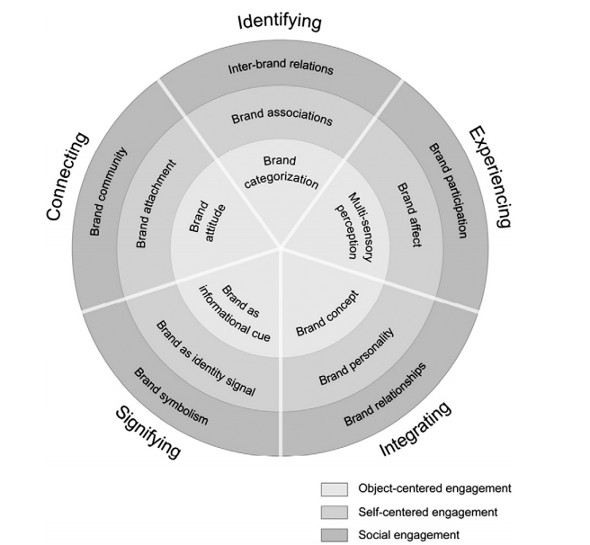

Figure 1: Consumer Psychology Model of Brands

Source:Hubert and Kenning (2008)

Thomson et al. (2005) have indicated that such structure of model may too reveals an awareness that consumers get at various levels towards psychological engagement with a brand due to various goals, motives and needs. Such levels of engagement has been depicted in the above model (Figure 1) by three different layers to explain consumer psychology that impacts consumer behavior towards a brand selection. The layer which is innermost demonstrate object centered and functionally-oriented engagement; information is acquired by the consumer regarding such brand with an intention to receive useful benefits from using such brand. The existing middle layer demonstrates a self-centered engagement; such brand may be perceived as individually relevant towards consumer. As a final point, such outer layer has been showing social engagement associated with such brand; it denotes that a brand selection depends on interpersonal as well as socio-cultural viewpoint, as well as gives a feeling of community.

Brakus et al. (2009) argued that all the researches have not been narrow and only empirically-focused. Such research also been relatively creative to generate new constructs, for instance, brand relationships, brand personality, brand community, brand attachment, self-brand connections (Thomson, MacInnis, & Park, 2005) as well as brand experience. These have been the methods to measure such consumer psychology and behaviours concepts as well as others like brand trust as well as brand love. However, this is not very clear about how such constructs link to one other as well as which particular role is played towards entire consumer psychology towards such brands. Though individual perceptual process results in multi-sensory views, majority of the research in psychology as well as consumer psychology could be on the basis of study of specific senses (Spence, 2010). Presently research has started exploring sensory attributes (such as intensity of depth of a color; light etc.) to impact consumer psychology that declines very fast. But, if consumers are given a method to put into code the sensory attribute expressively (for example, Tiffany Blue, Coca Cola Red), an improvement in memory towards sensory attributes can be seen radically (Carroll & Ahuvia, 2006).

**CONCLUSION**

Finally it can be concluded that consumer psychology has impact on consumer behaviour. As currently, the core theory of marketing is associated with customer centrality, it should not be ignored because customer decision-making process is involved with it. Culture and society highly impact consumer behaviours. As consumers are led by social class, family, subculture, membership groups, personality, psychological factors etc., marketers are presently making effort to develop an understanding of consumer emotions and psychology that can help them to remember or choose their brands by using various stimuli. Consumer decision making process includes information, culture attitude, societal aspects etc. Knowledge of consumer psychology and consumer behaviour is highly advantageous to develop brand attachment and brand awareness strategies. Sometimes brand selection is dependent on interpersonal and socio-cultural viewpoint that provides a sense of community. Thus, understanding consumer sensory attributes are the next level research that academicians and marketers are interested so that such sensory attributes can be included in their brands or products.

**REFERENCES**

Bayus, B. L. (2010), *Crowdsourcing and individual creativity over time: The detrimental effects of past success*. Working Paper Series. [Online] available at <http://papers.ssrn.com/sol3/papers.cfm?abstract_id=1667101> [accessed 12 April, 2015]

Brakus, J. Josko, Schmitt, B. H., & Zarantonello, L. (2009), “Brand experience: What is it? How is it measured? Does it affect loyalty?”, *Journal of Marketing*, 73, pp.52–68.

Carroll, B. A., & Ahuvia, A. C. (2006), “Some antecedents and outcomes of brand love”, *Marketing Letters*, 17, pp.79–89.

Haugtvedt, P.M. Herr, & F. R. Kardes (Ed.), *The Handbook Of Consumer Psychology*, (Pp. 1103-1131). Taylor & Francis Group, NY.

Hubert, M., & Kenning, P. (2008), “A current overview of consumer neuroscience”, *Journal of Consumer Behaviour*, 7, pp.272–292.

ISEN, A. M. (2008), Positive affect: Some recent theoretical developments with practical implications. In C. P. Haugtvedt, P.M. Herr, & F. R. Kardes (Ed.), the Handbook of Consumer Psychology, (pp. 273 - 296), Taylor & Francis Group, New York.

Loken, B. (2008), “Consumer psychology: Categorization, inferences, affect, and persuasion”, *Annual Review of Psychology, 57*, pp.453-485.

Schumann, D. W., Haugtvedt, C. P. & Davidson, E. (2008), History of Consumer Psychology. In C. P. Haugtvedt, P.M. Herr, & F. R. Kardes (Ed.), *The Handbook Of Consumer Psychology*, (pp. 3-28), Taylor & Francis Group, NY.

Shavitt, S., Lee, A. Y., & Johnson, T. P. (2008), Cross-Cultural Consumer Psychology. In C. P.

Spence, C. (2010), “Cross-modal attention”, *Scholarpedia*, 5, p.6309.

Thomson, M., MacInnis, D. J., & Park, W. C. (2005), “The ties that bind: Measuring the strength of consumers' emotional attachments to brands”, *Journal of Consumer Psychology*, 15, 1, pp.77–91.

Thomson, M., MacInnis, D. J., & Park, W. C. (2005), “The ties that bind: Measuring the strength of consumers' emotional attachments to brands”, *Journal of Consumer Psychology*, 15, 1, pp.77–91.

Woodside, A. G., Sood, S., & Miller, K. E. (2008), “When consumers and brands talk: Storytelling theory and research in psychology and marketing”, *Psychology and Marketing*, 25, pp.97–145.