**INTRODUCTION**

The report relates to management and finance that comprises multi-dimensional tasks. Basically the entire report is divided into three parts. In the first part theoretically there is identified the various stakeholders an organisation might have, and further some useful models of stakeholder analysis is discussed with reference to stakeholders interests. Next in the first part the case organisation Asda’s (British supermarket chain) practice is discussed in relation to what the different stakeholders of the company are, and how their interests are addressed. In the next part, the selected company Infosys's current position and strategy is discussed, together with assessing financial performance, as per the requirements. Lastly in the third part of the report, the investment and returns measurement is conducted in relation to the given case.

**1 : STAKEHOLDERS AND ASDA – UK Supermarket Chain**

One of the most frequent and standard approaches of classifying the diverse types of stakeholders is to include individuals groups who have categorical relations with the enterprise. In this framework, Friedman and Miles (2006) categorically put that there is an apparent connection amid classifying of what stakeholders are all about and in fact who are the stakeholders in an enterprise or firm. For them, the foremost groups of stakeholders include staff, clients/customers, participants in supply and distribution chain, communities in the location and shareholders. Further according to Friedman and Miles (2006), apart from these main stakeholders, there individuals and groups that may well be identified as secondary stakeholders including general citizens, media, partners in the venture, past generations and generations to come, competitors, non-governmental organisations, trade unions and trade associations, government authories make regulations for socio-economic and environmental well-being. Supposedly these identified and classified stakeholders in the forms of individuals and groups may well be categorised in the forms of internal and external. As such a classification becomes more categorical for the practitioners working for addressing the stakeholders interests in the organisations. Clearly, staff, clients/customers, participants in supply and distribution chain, communities in the location and shareholders can be categories as internal stakeholders. On the other hand, external stakeholders may well be included general citizens, media, partners in the venture, past generations and generations to come, competitors, non-governmental organisations, trade unions and trade associations, government authories. For a responsible organisation that believes in corporate governance needs to properly identify the internal and external stakeholders and address their issues and concerns categorised as interests. At the same time as it is as well noticeable that although organisations firstly concentrate on the concerns or interest of internal or primary stakeholders, yet considering the changing external environment it becomes imperative for organisations to address the concerns and interests of external or secondary stakeholders in true sense, without considering the direct effect and benefits. Obviously organisations may prefer to focus on internal stakeholders considering the direct effect of their role on profit and business growth. There are a range of theoretical frameworks and models are obtainable for analysing the interests of stakeholders in the organisation, however practitioners in the organisations need to look for effective and vigorous models, so that more results might be obtained with comparatively less input required. Let us discuss some useful frameworks and models.

In accordance with Cennama, Berrone and Comez-Meija (2010), the theoretical premise of stakeholder establishes that a connection flanked by strategy and principles is likely if the requirements of a huge collection of components are taken into consideration and a foremost issue of concern in this context is that as is how the economic interests of the organisation may well be balanced by means of the principled and socio-economic interests of stakeholders. In this framework of understanding, Noland and Phillips (2010) draw our attention towards two well-known fresh drifts in the text as regards stakeholder engagement, which implies that ethical engagement is noticed through explicit situations communication which make certain that this communication is unspoiled by influence divergence and strategic impetuses. The ethical strategists in this context contend that that the engagement of stakeholders ought to be fundamental to an organisation’s strategy if it is to accomplish true victory and further they put that first-rate strategy correctly acknowledged ought to include what are characteristically documented as ethical concerns, for the reason that the very idea of the organisation and the entrepreneurial classification is making of value for every stakeholder (Lingren and Swaen, 2010, p1).

In the framework of balanced approach of addressing stakeholders interest with firms goals, and further in relation to ethical, and socio-economic strategy, Sinclair (2012) develops an effective model of stakeholder engagement made of five components in the forms of Framework, Annual Review, Systems/Process Integration, Communication and Training and Implementation. Adopting this model will enable an organisation to properly address the concerns and interests of every stakeholder.



Source: Sinclair (2012)

So far as the case organisation ASDA[1] is concerned, the foremost stakeholders at the centre of organisation's strategy are employees, customers, suppliers, shareholders, community and government. This suggests that ASDA give recognition more to internal or primary stakeholders, nevertheless, the organisation does not completely overlook the recognition of external or secondary stakeholders. Giving recognition to employees, customers, suppliers, shareholders and community, is quite typical from the conventional approach of stakeholder perspective of conducting business. However, the company's recognition of governments as stakeholder makes sense, but truly the recognition is not adequate considering the long list of secondary or external stakeholders in the forms of general citizens, media, partners in the venture, past generations and generations to come, competitors, non-governmental organisations, trade unions and trade associations. More importantly, the company does not appear to have a standard model of addressing the interests of both primary and secondary stakeholders. Typically, the internal stakeholders concerns are addressed as per their contribution in company's financial performance. But the company needs to look beyond that. There needs to be taken a balanced approach of stakeholder interests. As Noland and Phillips (2010) draw our attention towards two well-known fresh drifts in the text as regards stakeholder engagement, which implies that ethical engagement is noticed through explicit situations communication which make certain that this communication is unspoiled by influence divergence and strategic impetuses. In this background, ASDA is suggested to take on the Stakeholder Engage Model of Sinclair (2012) comprising five components in the forms of Framework, Annual Review, Systems/Process Integration, Communication and Training and Implementation. The company may focus on particular component considering the internal and external requirements and urgency.

**2 : INFOSYS – CURRENT BUSINESS POSITION, PLANNING AND STRATEGY, FINANCIAL POSITION**

The India based Infosys Ltd is a worldwide leading IT related services Provider Company. Thecompany is a public limited business entity and ranks second largest when it comes software export from India are concerned. Infosys Ltd was founded in 1981 named as Infosys Consultants Pvt Ltd by well-known name in the IT sector Mr.N.R.Narayana Murthy at Karnataka, the Southern state of India. The company is headquartered in Bangluru. Narayana Murthy had started this venture with the help of seven people with the investment of USD 250. The company done well in its startup and growth phase, and hence became a public limited company in 1992. The most notable and creditable recognition so far of Infosys is that it was the first Indian company to be listed on the NASDAQ. The company was listed on the NASDAQ in 1999. More importantly, the company as well forms a part of the NASDAQ-100 index.

The operation of Infosys Ltd revolves around defining, designing and delivering IT-enabled business solutions to the clients situated in different parts of the world including. The company's main global clients are based in US and various European countries. Infosys primarily offers end-to-end business solutions that control technology for their clients, comprising technical consulting, design, development, product engineering, maintenance, systems integration, package-enabled consulting, and implementation and infrastructure management services. Apart from these, as well offers software products to the banking and financial sectors, it would be worth to mention here that Infosys have developed *finacle*, a standard banking and financial solution to large and medium size banking organisations all through India and global the world. Infosys as well has a unit of BPO, which a company owned subsidiary. By means of this subsidiary organisation, the company offers business process management services, in the forms of offsite customer relationship management, finance and accounting, and administration and sales order processing. In order to ensure smooth functioning of various operations, Infosys has formed marketing and technical coalitions with FileNet, IBM, Intel, Microsoft, Oracle and System Application Products.

The current financial position of Infosys Ltd is exceptional with $7 billion. The net profit of the company has reached Rs 9116 crore in 2013, from Rs. 8470 crore in 2012 (Moneycontrol, 2014).

It becomes quite apparent from the above description that Infosys Ltd current position is exceptional and unparrarel whether it is financial position or non-financial position. So far as the non-financial position is concerned, the company stands second largest software exporter from India, and further its global position is strengthening with the passage of time through developing innovative software solutions and forming strategic alliances. The company has successfully formed marketing and technical coalitions. It is because that even during the time of turbulance, the company has done well in expanding its business both within and outside of the country. When it comes to financial position, the company's financial asset is unparalleled for the competing companies in the industry, and at a time when its competitors loosing finance in the market, Infosys is recording new highs in every quarter. This strong position of Infosys is nothing uncharacteristic for the company, ever since it took flying start in 1981. Obviously the company's business planning and corporate strategy is explosive, however considering the intensifying competition and low threat of entry, the company needs to evaluate its current business planning and strategy in order to keep up the current position and performance. Let us discuss how the current planning is and strategy is working, and what new planning and strategies require for future sustainability and growth.

Infosys Ltd has had long been far ahead in its corporate strategy comparing the strategies of companies operating in the similar IT sector. The company's foremost planning and strategic action has had been to keep up high standards of governance and transparency, and rewarding best in the industry to the employees where offering a stock option programme has set standard for the companies not only in India but globally. In this framework of business planning and strategic action, the company has focused more on higher-value software and consulting that may well be put into practice all through clients and less on labour-intensive simple vanilla outsourcing services. In accordance with this strategic planning and philosophy the company offers software products for various industries, though its business concentration has been on banking and financial sector. Even the company has exploited the opportunities in BPO sector establishing a subsidiary unit. The company has believed as well in the strategy of strategic alliances, and has entered in various global markets with the entry mode of strategic alliance. However, the trouble for the company is that it is shifting gears at a time whilst its business clients in the United States and Europe are tightening their belts, and its competitors both from India Such as Tata Consultancy Service is posing huge challenge (Reuters, 2012). The strategic alliances abroad definitely going to help the company, but the fact is that the company needs to remodel its business planning and strategy. The company needs to take the route of focus which a strategic hybrid of differentiation and cost leadership. More importantly, the company needs to make huge investments for intensifying its differentiation in order to block the threat of new entrants and gain an edge over the competitors. Apart from these, the company as well needs to reduce the threat of new products, as more and more software products are introduced by various companies for banking and financial sectors. Infosys has opportunity to develop cost effective software products for government projects both within and outside the country.

# Due to global financial crisis, Infosys has had struggled in recent years to meet up the expectations of shareholders expectations. This is evident from the fact that the Equity Share Capital of the company has remained Rs. 287 crore for the last three years. However, financial performance has improved in terms of net profit. As evidently, the net profit of the company has reached Rs 9116 crore in 2013 from Rs. 8470 crore in 2012 (Moneycontrol, 2014). The point is that surely investors’ confidence is low in Infosys considering the steady Equity Share Capital of the company for the consecutive three years. Definitely this is the effect of global financial crisis, but the rising profits of the company must give some confidence to the investors. More importantly, the company needs to introduce some incentives to its shareholders or investors for the future financial well-being of the company.

**3: INVESTMENT ASSESSMENT TOOLS**

As according to Maher et al. (2011), a company's decision regarding capital investment decision generally entails a large degree of investment once or even incessant, however, the intricacy arrives before the company in the case it has more than one choices of investment; and moreover, the intricacy turns out to further composite whilst the investment is in fractions with the passage of time. It is in this framework, that prevailing over such intricacies and deciding the most appropriate and money-making investment decisions, the company has obtainable investment assessment tools in the forms of Payback Method(PM), Accounting Rate of Return(ARR), Net Present Value (NPV) and Internal Rate of Return (IRR)

***PM – Payback period***

As according to Kinney and Raiborn (2010), PM is the most common and trouble free tool of investment assessment to discover and calculate the digit of years necessary to recuperate the capital expenditure. This method is trouble-free to construe and measure, and offers best decision for making plain investments. However, this method is disadvantageous considering its failure to acknowledging interest rate.

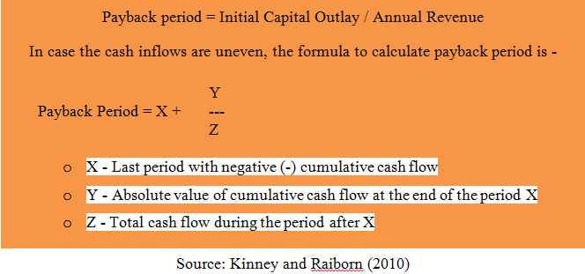

With reference to the investment assessment through PM, various suppositions are made, by means of measurements and assessments. Firstly investment choices in various countries are considered as project, where living of the project in every country is taken considering five years, and therefore all measurements for project assessment is carried out for five years. Next salvage value of machinery (£150k) subsequent to five years are comprised in the forms of cash inflows of fifth year. On the other hand, scrutiny fee by the Swiss authorities for all three years (£70K) are comprised in the first and forth years of cash outflows. Furthermore, depreciation is measured using straight line method (£450k - £150k/ 5 = £60k). Apart from these, every l cash flow facts applied for measurement are in ‘000s, not including discount rates. Finally for comparing and measuring the cash flows and result of investment assessment every one of currencies is converted into domestic currency ‘sterling pound’ (£). The conversion rate is presented in the Table.

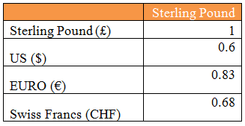

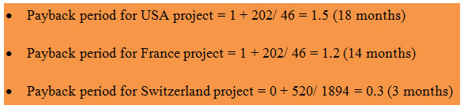

*Payback Period**(see appendix #1)*

The conclusion emerges that the project in Switzerland has feasibility and power to recover the investment in just about 3 months of investment which is lowest in the midst of the entire projects in different countries. Therefore 123 Ltd. must invest in Switzerland so far as its proposed project investment is concerned.

***NPV***

As according to Maher et al. (2011), NPV tool makes use of discount rate to measure current value of cash flows. Furthermore, as according to Baker and Powell (2009), NPV may well capture diverse discount rates to replicate the scale of risk for jointly private project. The plus points linked with NPV tool is that it reflects on current value of upcoming cash flows, and as well the tool is facilitating for jointly private projects. However, there are some negative points as well associated with NPV, where the most notable is its not measuring the risks connected with the investment.

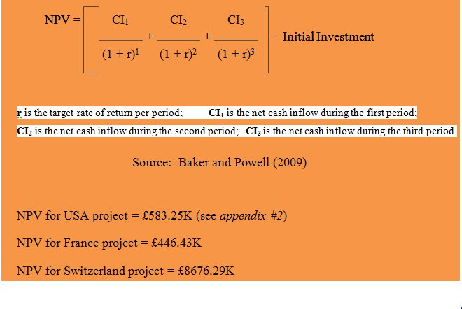

NPV investment assessment too reveals that project investments in Switzerland presents highest value (£8676.29K) in the midst of investment projects in various given countries. Therefore, 123 Ltd. is suggested to invest in its projects to be carried out in Switzerland, prioritising over other countries.

***IRR***

So far as the investment assessment tool IRR is concerned, as according to Maher et al. (2011), IRR is the rate of discount rate at which current value of upcoming cash in-flows are equivalents to current value in terms of cash out-flows, where such as NPV tool, IRR as well reflects on the time value of money. The plus points linked with IRR are that it as well reflects on current value of upcoming cash flows. However, there is one major negative point connected with IRR, and it is that the tool fails to acknowledge the risk linked with the investment.

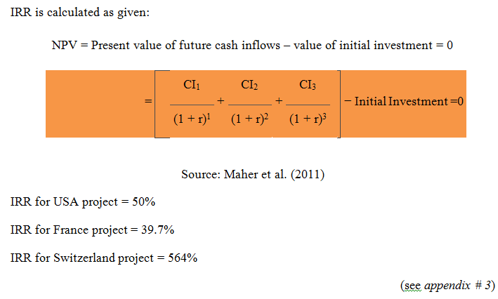

As per investment assessment by means of IRR, project investment in Switzerland is going to present highest IRR (564%) to 123 Ltd in the midst of project investments in other countries. Therefore 123 Ltd. must look forward to invest in Switzerland.

**CONCLUSION**

In this report three specified tasks have been successfully completed with the utmost satisfaction level. The report has been made ready conducting only secondary research. No primary research was conducted. Yet the results and analysis in the report are of no less value.

The obtained results and analysis conducted in the first task conclude that the foremost stakeholders of ASDA are employees, customers, suppliers, shareholders, community and government. The company is found giving recognition more to internal or primary stakeholders, nevertheless, the organisation does not completely overlook the recognition of external or secondary stakeholders. However, truly the recognition is not adequate considering the long list of secondary or external stakeholders in the forms of general citizens, media, partners in the venture, past generations and generations to come, competitors, non-governmental organisations, trade unions and trade associations. The analysis as well makes known that ASDA does not appear to have a standard model of addressing the interests of both primary and secondary stakeholders. Therefore, the company needs to look beyond that. There needs to be taken a balanced approach of stakeholder interests. Considering this ASDA is suggested to take on the Stakeholder Engage Model of Sinclair (2012) comprising five components in the forms of Framework, Annual Review, Systems/Process Integration, Communication and Training and Implementation. The company may focus on particular component considering the internal and external requirements and urgency.

Furthermore, the obtained results and analysis conducted in the second task conclude that Infosys Ltd current position is exceptional and unparrarel whether it is financial position or non-financial position. This strong position of Infosys is nothing uncharacteristic for the company, ever since it took flying start after coming into existence. The company's business planning and corporate strategy has had been high power, however considering the intensifying competition and low threat of entry, the company needs to evaluate its current business planning and strategy in order to keep up the current position and performance. The strategic alliances abroad definitely going to help the company, but the fact is that the company needs to remodel its business planning and strategy. The company needs to take the route of focus which a strategic hybrid of differentiation and cost leadership. Infosys has opportunity to develop cost effective software products for government projects both within and outside the country. The investors’ confidence is low in Infosys considering the steady Equity Share Capital of the company for the consecutive three years, and therefore the company needs to introduce some incentives to its shareholders or investors for the future financial well-being of the company.

Finally the obtained results and analysis conducted in the third task conclude undoubtedly diverse project assessment tools employ dissimilar statement and technique of computation for assessing a project, nevertheless finally these attempt to direct the company for the finest offered investment choice. The results and analysis clearly point towards the fact that the case company 123 Ltd must go for investing in Switzerland, considering the fact that investment in this country would be best choice and most benefiting for 123 Ltd.

BIBLIOGRAPHY

ASDA (2012), “ASDA Sustainability Report”. [Online] available at <http://your.asda.com/sustainability> [retrieved on 12/4/2015]

Baker, H.K. and Powell, G. (2009), *Understanding Financial Management: A Practical Guide*, John Wiley and Sons, NY.

Cennamo, C., Berrone, P. & Gomez-Mejia, LR. (2010), “Does stakeholder management have a dark side?”, *Journal of Business Ethics*, 89, pp.491-507.

Friedman, A.L. and Miles, S. (2006), *Stakeholders: Theory and Practice*, Oxford University Press, Oxford.

Infosys Ltd (2014) “Company Profile”. [Online] available at <http://www.indiainfoline.com/Markets/Company/Background/Company-Profile/Infosys-Ltd/500209>[retrieved on 12/4/2015]

Kinney, M. and Railborn, C. (2010), *Cost Accounting : Foundations and Evolutions,* Cengage Learning, London.

Maher, M., Stickney, C. and Weil, R. (2011), *Managerial Accounting: An Introduction to Concepts, Methods and Uses,* Cengage Learning, UK.

Moneycontrol (2014), “Balance sheets of Infosys”. [Online] available at <http://www.moneycontrol.com/financials/infosys/balance-sheet/IT#IT> [retrieved on 12/4/2015]

Noland, J & Phillips, R. (2010), “Stakeholder engagement, discourse ethics and strategic management”, *International Journal of Management Reviews*, 12, 1, p39.

Reuters (2012), “Infosys premium position is a liability for Indian”. [Online] available at<http://www.firstbiz.com/corporate/infosys-premium-position-is-a-liability-for-indian-it-31016.html>[retrieved on 13/4/2015]

Sinclair, M. (2012), “Developing a Model for Effective Stakeholder Engagement Management”. [Online] available at <http://www.deakin.edu.au/arts-ed/apprj/articles/12-sinclair.pdf> [retrieved on 12/4/2015]

**APPENDIX**

**Appendix # 1 : Payback Period Estimation**

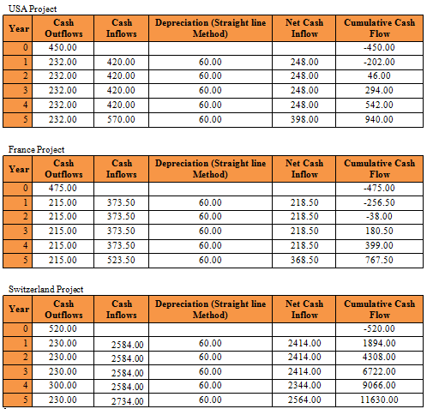

**Appendix # 2 : NPV Estimation**

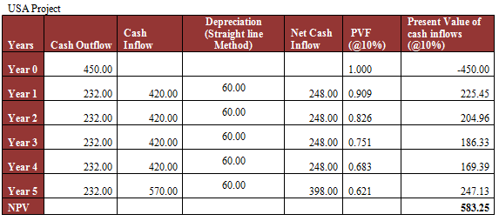

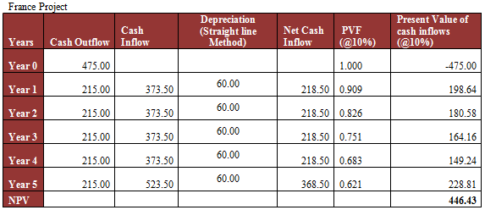

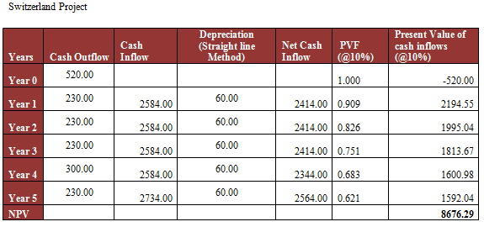

**Appendix # 3 : IRR Estimation**

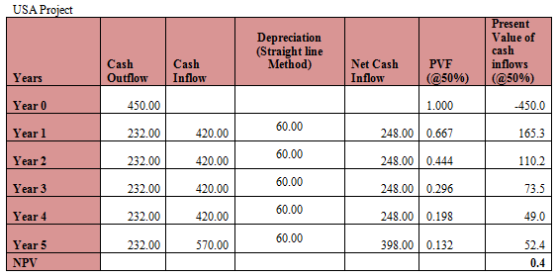

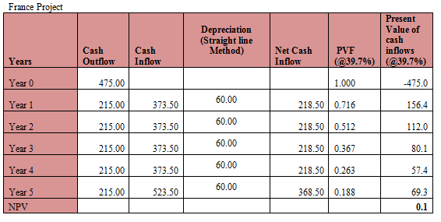

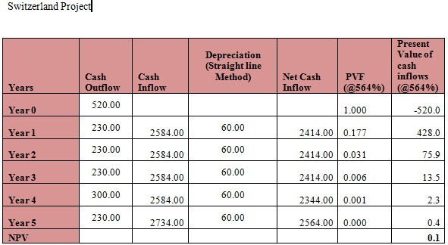

1. Asda Stores Ltd. is a British supermarket chain which retails food, clothing, general merchandise, toys and financial services.