**Organizational Behavior**

**INTRODUCTION**

In this study an effort has been made to understand various theories of leaderships to understand its significance in organizational effectiveness. The major heads discussed in this study are: leadership in motivation and employee relation, organizational culture and its impact on organizational effectiveness, organizational structure and culture and its impact on organizational effectiveness of Wipro, approaches to organizational decision making, theories related to management approaches under uncertainty, evaluation of effectiveness of organizational decision making of Wipro.

**Company Profile**

Wipro Ltd is an information technology consulting and outsourcing company having global presence, its employee strength is 156,866 providing services to its clients at 175+ cities in 6 continents. The revenue posted by the company is $7.3 billion during year ending of 2014 (Wipro Limited, 2015).

**LEADERSHIP IN ORGANIZATIONAL EFFECTIVENESS**

According to Erkutlu (2008) Leadership may be defined as technique of social influence. Leaders need to exercise influence that followers should accept as well as respond towards the persuasion of the leader. Followers or groups in the organization make decision regarding if an individual must be given leadership status through evaluating a presented individualities or image towards profoundly held expectations regarding what makes a dependable leader towards organizational effectiveness.

Transformational Leadership Style impacts transactional behavior where cooperation may be taken through instituting giving rewards that impact on organizational effectiveness. There are two features which are most central towards such expectations that are task-oriented competency as well as trustworthiness. During early phase of relationship a leader-follower, decisions on such characteristics remain dependent upon impression as well as image, however as time passed by, it dependent on experience as well as evaluation. Without any credibility, there may not be any leadership (Zhang, and Bartol, 2010).

According to Wang (2009) Executive’s Leadership Style of a company has an important, direct as well as positive impact on organizational culture, organizational learning and organizational commitment. The previous theories about leadership explained that it is perceived as personal capability. But, Jing and Avery (2008) have opined that the extent, to which an individual represents leadership, relies upon characteristics as well as personal capabilities, features of a location as well as environment where he identifies himself. Additionally, Messick and Kramer (2004) have stated that leadership is about achieving teams’ objectives in which they remain as an active member and it relies on the way they manage their team and convince them to attain predetermined organizational objectives.

Ru-hsuen Hsiao (2011) Directive Leadership Style makes subordinates familiar with expectations of their leaders when providing them guidance regarding how every task must be accomplished. According to Zhang, and Bartol (2010) leadership remains the "decision-maker" of organizational intelligence. Such leaders should develop as well as encourage norms, rules and roles towards efficient application towards recognized tasks, however should also remain sensitive as well as responsive towards change through engaging sensitivity, decision making strategies and problem solving which allow towards adaptation.

Fry and Whittington (2006) have stated that a “leadership” style impacts upon deployment of colleagues through a consensual, group effort to attain vision of the organization. Such mobilization or deployment might also include certain real managerial limitations. For instance, organizations should not only remain effective towards implementing such strategy, however also effective. The profit should also supplement mobilization of resources of the management as well as organization should be adjustable towards both external demands towards change as well as internal processes for meeting customer requirements as well as employee demands.

The effectiveness of leadership remains basically the exercise of the subsequent principles (Rawung, 2012):

1. Develop a collective mission, vision as well as set of value which assists employees focusing on their contributions as well as deliver their best to the organization.

2. Establishing an effective communication environment which encourages correct as well as authentic feedback as well as self-disclosure.

3. Keep information readily accessible.

4. Establishing respect, trusts as well as peer-based behavior like a norm.

5. Remaining inclusive as well as patient, need to show concern for every person.

6. Demonstrate creativity as well as the readiness to learn.

7. Creating an environment which inspires extraordinary performance.

Ekeland (2005) has stated that organizational effectiveness is highly influenced by leadership effectiveness which needs providing attention towards dimensional behavioral aspects. Apart from providing attention towards direct reports, a leader requires paying attention towards three other dimensions such as: 1. Sustaining focus and clarity on managerial goals 2. Must have capability to provide required support towards individuals to conduct their work as well as fulfill their objectives 3. Should enable interactions with each other among subordinates to develop competences, good morale, as well as teamwork. These dimensions are considered as segment of leadership that improves business performance.

**Contemporary Leadership in Motivation and Employee Relation**

Leadership plays a significant role in improving morale and motivating employees at work. Motivation among group of associates needs effective leadership as well as should be proficient towards drive to attain objectives formerly defined. Watkiss (2004) has stated that, motivation remains towards driving a person towards doing something. Many of them are driven with a view to potential reward, or a concern of not performing. Motivation remains forces for which employees does something: it is an outcome of satisfaction of individual needs so as to individual is having inspiration towards accomplishing such task. Motivation denotes towards direction, initiation, intensity as well as perseverance of human behavior. Employee motivation remains a concept as well as initiative towards encouraging as well as driving such individual to carry out something or in performing better jobs.

According to Sidani, (2007) the key motive towards organizational existence is not just to survive, however also to earn profit as well as towards competing in competitive environment towards locally or globally. So as to in attaining such missions, organizations need satisfying employees those are considered like a cornerstone for several companies. Therefore, such employees will have a better morale, self-esteem as well as also have feeling of comfort at their work place. But, this is tough to make argument that a workplace where employees are motivated denotes that such companies would obtain high performance, or maybe would enhance revenue. But, managers are required taking actions for satisfying employees as well as thus; this is supposed to grow motivation of employees (Dubrin, 2007). After growing motivations, such employees would work even harder as well as feel that such employees are accountable in attaining every target as well as goal that is instructed by their supervisors. In another words, it denotes that, employees will sense that such organization as belongs to them. For an example, motivation process might have several impacts regarding how employees learn as well as behave in an organization (Sidani, 2007). This may direct towards attaining a specific behavior, which leads towards growing effort as well as energy and it brings positive behavioral change among employees that increases organizational effectiveness.

According to Mullins and Christy (2013) expectancy theory however, brings attention towards the difficulties of work motivation. This gives additional information to help and explain such nature behavioral aspect as well as motivation towards work situation as well as assists in identifying issues in performance. Expectancy theory denotes that leaders must focus towards a several aspects that include the following:

■ Application of rewards must be done appropriately as per individual employee performance. Outcomes having high value must be supported through incentive in improving further performance.

■ Effort in establishing strong relationships between activities– performance as well as rewards, as seen by an employee (Rawung, 2012).

■ Setting clear procedures in evaluating individual performance level.

■ Paying attention towards intervening variables likes traits and abilities, perception of roles, organizational process as well as support facilities that though not essentially factors towards direct motivation, still might impact performance.

■ Minimizing undesirable results that may be seen outcome through a higher level performance, like industrial accidents or approvals from co-workers, or layoffs or short-time working.

Mullins and Christy (2013) have also focused on expectancy model that such expectancy theory uses solely behaviors that are under the intentional control of an individual. Such two general categories of choices on regarding which person have voluntary controls on performance of an organization that are describing about to:

a) The extent of effort as well as energy spent; as well as

b) The manner through which it moves towards performing its work in the organization.

**ORGANIZATIONAL CULTURE AND ITS IMPACT ON ORGANIATINAL EFFECTIVENESS**

Dasanayaka and Mahakalanda (2008) have stated that, maximizing values of the employees are perceived as rational assets which needed a culture towards supporting their rational participation for individual as well as organizational learning, developing new knowledge and willingness to share knowledge with others. Organizational culture remains highly significant presently as compared to the past. It claims that such organizational culture remains linked with performance which is introduced upon apparent role that culture can play in attaining competitive advantage. According to Kerr and Slocum (2005) overcoming few limitations to measure such culture of an organization. Finally, outcomes indicate that no positive correlations exist between culture as well as employees performance. Once it is reviewed critically by such contemporary researches, this may be expected that a role is there of culture and it is a link between culture as well as performance. It is also argues by the theorists that creating a culture of organizational competencies leads towards sustainable competitive advantage that are superior as well as imitable incorrectly by the competitors. Academics as well as practitioners recommended that such organizational performance (Figure 1) is reliant upon extent to which such cultural values are shared comprehensively.

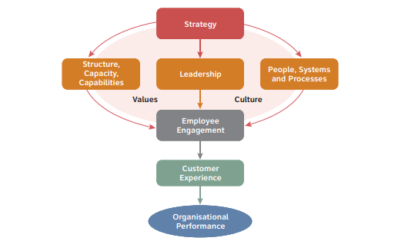

Figure 1: Organizational Effectiveness Framework

Source: Right Management (2009)

**ORGANIZATIONAL STRUCTURE AND CULTURE AND ITS IMPACT ON ORGANIATINAL EFFECTIVENESS OF WIPRO**

When it comes to the organizational structure and organizational culture, Wipro has taken initiatives in redesigning its IT organization through reviewing such state of organizational structure of the company, leveraging company’s values of an effective organizational structure in deciding aspects in which effectiveness may be improved. In case of Wipro effectiveness in a situational intelligence solution depends upon collaboration throughout such general organizational silos. Getting more as well as improved technology competency may enable it; however, such absolute fundamental remain an organizational structure as well as culture which encourages and enables collaboration and improve organizational effectiveness. Several organization structures are there that may enable this. For example, an organization is conducting a vital re-think of the roles as well staffs’ accountability of control room (Wipro, 2010).

In case of Wipro, culture is highly given importance and the company perceives employees like highly valuable asset in the organization. Employees create fundamental system of Wipro as well as the growth as well as evolution which is ascribed towards them. The leadership team in Wipro then precisely devotes towards a considerable emphasis on developing as well as furthering such intellectual potential of the people at Wipro. With an objective to develop the best global leadership, Wipro nurtures its talent with kindness as well as confidence to attain organizational effectiveness. Wipro gives it people a transparent as well as level-playing environment of work which promotes the culture of meritocracy, collaborative work as well as on-the-job career progression (Wipro, 2010).

The investments of the company towards intellectual capital remain aiming towards empowering employees for creating positive impact from customer. Towards such journey of simplification of an organization structure needs to be accomplished, this is crucial that such consumers facing employees remain empowered for making them enable to take faster decision making (Wipro, 2010).

**APPROACHES TO ORGANIZATIONAL DECISION MAKING**

According to Drucker, P. F. (2010) a company consist managers those take decisions by adopting both such rational as well as intuitive procedures; however decisions on organization-level are not generally taken by any single manager. Various organizational level decisions involve various managers. Identification of problem and solution to a problem includes several departments, even input from other organizations as well as multiple viewpoints which are beyond a specific manager’s scope.

**Scientific Management Approach**

As stated by Hartnett, T. (2011) that fundamental concern about scientific management approach was enhancing worker’s efficiency mainly by means of proper job designing as well as providing appropriate training to the workforces. According to Taylor by properly doing job design, selection of employee, training as well as incentives to employees, productivity may be enhanced that impacts organizational effectiveness and organizational development. Such scientific management approach encouraged that efficiency might be achieved through identifying right approach to get the work done, by mean of specialization upon job, through planning as well as scheduling through use of standard operational mechanisms, setting standard times to conduct the job, through appropriate selection as well as training personnel training as well as by means of providing wage incentives.

**Carnegie Model**Mintzberg (2008) have stated that Carnegie model approach in organizational decision making facilitated in formulating limited rationality approach in case of individual decision making and in giving new understandings regarding organizational decision.

According to March, J. G. (2010) Carnegie model identified that developing agreement by means of a managerial coalition remains a main segment towards organizational decision making. It is mostly accurate at top level management. Discussions as well as negotiating remain time-consuming, thus search processes are generally simple as well as chosen alternative satisfices instead of optimizing solution to the problems. While problems remain programmed - remain clear as well as have been perceived earlier – such organization would depend on past routines as well as procedures. Rules as well as procedures prohibit the requirement of renewed coalition development as well as political bargaining. In an organization, non-programmed decisions but need bargaining as well as conflict resolution.

**Incremental Decision Process Model**

According to Mintzberg, H. (2008), the associates and Henry Mintzberg of McGill University explored organizational decision making approaches through several perspectives. It found twenty-five decisions that were made in the organizations as well as outlined events linked with such decisions from start to end. The study explored every step in a sequence of decision. Such approach in organizational decision making is termed as incremental decision making model, that gives less importance on social and political factors which is depicted in Carnegie model, however, informs much regarding structured system of activities adopted through finding a problem till obtaining a solution (Pugh, 2007).

**High-Performance Organizations (TQM Approach)**

Pugh, (2007) have stated that high-performance organizations have goal to utilize intellectual capital efficiently and effectively. High-performing organizations emphasize upon employee involvement, organizational learning, teamwork, total quality management (TQM), as well as integrated production systems. Employee engagement is attained by means of worker empowerment or through participative management. Teamwork could be accomplished with the help of self-directed groups. In this scenario organizational learning includes collecting, communicating, as well as storing information to predict future challenges and changes by making more informed decisions regarding future. Under this approach transforming an organization towards high-performing organization starts through actively identifying and understand work site issues to improve quality and fulfill mission, strategy, as well as vision of the company.

**Centralization and decentralization**

According to Pugh (2007) approaches towards decision making opportunity is provided at the top or through lower level decides on the basis of whether organization remains centralized or decentralized.

a) Top management takes major decisions without taking any input from low level employees, such organization is centralized.

b) When employees at lower level are given more input as well as given more choice to take decision, this is called decentralized.

c) Such effectiveness of centralization approaches of or decentralization approaches rely on several aspects like size of the company, environment, employees, strategies, technology etc.

**Human Resources (Supportive) Approach**

According to Widyanto and Sutarno, (2011) human resource approach is a developmental approach associated with development and growth of people towards creativity of higher levels of competency, since employees remain fundamental resource towards any organizations. This assists workforce in the organization to grow through responsibility and self-control as well as then this makes an effort to develop an environment where every employee can contribute towards limitation of their enhanced capabilities. In this approach it is considered that enhanced capabilities as well as opportunities towards people would lead directly towards improvements in operational effectiveness in the organization. Fundamentally, such human resources approach denotes that creating better people is about attaining better outcomes.

**A Systems Approach**

It denotes that organization comprises several inter related as well as inter dependent components impacting each other in order to attain overall outcomes. Theoretically a system denotes that multitude variables of an organization as well as each of that impact all others through complex relationships. The event seems to impact one department or one department essentially might have important impacts elsewhere towards organization.

Greenberg (2011) has stated that description of organization given by systems theorists is as “open towards its external environment”, obtaining some inputs through environment like human resources as well as engaging towards several operations for transforming such raw materials towards a finished products as well as ultimately turning out such “outputs” towards its final procedure to be forwarded to the environment. Such organization, as this is open to such environment, also obtains feedback through environment as well as takes corrective measures as required.

**Management Approaches under Uncertainty**

According to Scott-Ladd, and Marshall (2004) Carnegie model explored that developing agreement by means of a managerial coalition (Figure 2) remains a significant aspect in organizational decision making. It is particularly applicable at upper level of management. If issues are programmed remain clear as well as have been perceived before– such organization would depend on past routines and procedures. Scott-Ladd and Marshall (2004) have also stated that among the effective visible coalition builders would look for a broad-based coalition during beginning of a significant decision making process. If senior managers are not in a position to develop a coalition around such goals as well as priorities of the priorities, such outcomes may be a disaster and hinders in satisfactory decision making.

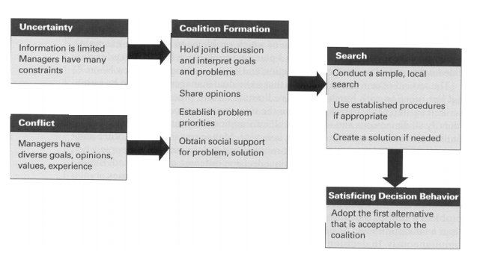

Figure 2: Decision Making Under Uncertainty

Source: Scott-Ladd, & Marshall (2004)

**Evaluation of Effectiveness of Organizational Decision Making of Wipro**

**Risk Management at Wipro**

When it comes to uncertainty and risk management of Wipro, the company has core team who look after several risk management areas (Figure 3) such as (Wipro, 2010): Alliance Risks, Climate Change& Sustainability, Country (Geo-Political) Risks, Business Continuity& Disaster Recovery, Employee Safety & Physical Security Risks, Infrastructure &Operations Risks, Fraud Risks, Emerging Technology Risks, Governance &Policy Compliance, Information Security & Compliance, Intellectual Property Risks, People Engagement & Supply Chain Risks, Regulatory Compliance including Employment, Immigration and Tax laws, Systemic Vulnerabilities etc.

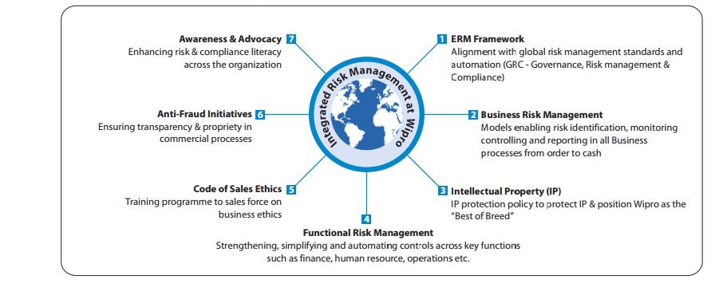

Figure 3: The Different Streams of ERM Deployment in Wipro

Source: Wipro (2010)

The company’s risk management framework could be used in assessing the risks towards engagement having crucial alliance partners. The major risk indicators like a financial stability, delivery performance and viability of alternates could be assessed as well as mitigated (Wipro, 2010).

Wipro also adopted role based training programs for enhancing decision making skills by measuring uncertainty and risk and it managed delivery risk management (Wipro, 2010).

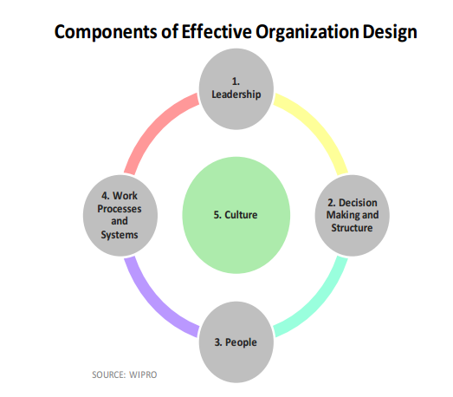

Figure 4: Components of Effective Organization Design

Source: Wipro (2012)

Wipro has an effective decision making components. The above mentioned diagram (Figure 4) explains that Wipro emphasizes that leadership remains major component which is required towards an effective organization redesign. Leaders should have a strong vision of the growth as well as remain capable of prioritizing tasks towards empowering such workforce as well as motivate such groups behind transformational agenda of the management in retooling such IT organization. Unity in a leadership team remains vital as well as Wipro considers this is the link which binds a transformation as well as leads efforts through creation of idea to implementation. As a leader needs employees to remain flexible, Wipro undergoes operational enhancements as well as process shifts, leaders should possess capacity towards change as well as should stand by their message for enhancing organizational effectiveness as demonstrated in Figure 4 (Wipro, 2012).

Clear decision making as well as structure remains a second component in effective organizational design, since roles as well as accountability towards decisions should be clearly articulated, transparent as well as understood towards establishing transformation ownership. Organizational structure should support general objectives of restructuring or consolidation for providing a chain of command which gives a clear track towards inquiries as well as clarity for every organizational layer (Wipro, 2012).

People create third pillar for effective organization design, since effective redesign hinges upon employees’ capabilities for performing both individually as well as collectively like an organization. For driving productivity as well as employee satisfaction at the time of turbulent times, the leaders in Wipro believes that they should implement performance actions as well as incentives which are closely aligned with corporate objectives. Alliance of employees throughout such organization remains critical towards an effective transformation, reducing risk or uncertainty of inefficiencies which might arise from any disparate workers (Wipro, 2012).

As per the above diagram fourth pillar which is Work Process and Systems explains implementation of programmatic work as well as processes successfully as well as effective as well as efficient support towards processes as well as systems. Then the last pillar, Culture, includes high-performance behaviors and values and willingness and capacity to change like a group (Wipro, 2012).

**CONCLUSION**

Leaders need to exercise influence that followers should accept. Transformational Leadership Style impacts transactional behavior where cooperation may be taken through instituting giving rewards that impact on organizational effectiveness. High-performing organizations emphasize upon employee involvement, organizational learning, teamwork, total quality management as well as integrated production systems. Organizational effectiveness is highly influenced by leadership effectiveness which needs providing attention towards dimensional behavioral aspects. Motivation process might have several impacts regarding how employees learn as well as behave in an organization. Basically, human resources approach denotes that creating better people is about attaining better outcomes. Enhanced capabilities as well as opportunities towards people would lead directly towards improvements in operational effectiveness in the organization. Academicians have recommended that such organizational performance is dependent on extent to which such cultural values are shared comprehensively. The company’s risk management framework could be used in assessing the risks towards engagement having crucial alliance partners. For driving productivity as well as employee satisfaction at the time of turbulent times, the leaders in Wipro believes that they should implement performance actions as well as incentives which are closely aligned with corporate objectives.

**REFERENCES**

Dasanayake, S. W. S. B and Mahakalanda, I. (2008), “A Literature Survey on Organizational Culture and Innovation”, *Global Business and Management Research*, Boca Raton, Florida pp.539-550.

Drucker, P. F. (2010), *The Practice of Management*, HarperCollins, NY.

Dubrin, A., J. (2007), *Leadership research findings, practice, and skills,* 5th edition, Houghton Mifflin Company, Boston, NY.

Ekeland, T., P. (2005), *The relationship among affective organizational commitment, transformational leadership style, and unit organizational effectiveness within the corps of cadets* at Texas A & M University.

Erkutlu, H. (2008), “The impact of transformational leadership on organizational and leadership effectiveness: The Turkish case”, *Journal of Management Development* 27, 7. pp. 708-726.

Fry, L., W. & Whittington, J., L. (2006), Avolio, B., Gardner, W. & Walumbwa, F. (Eds.). “Authentic Leadership Theory and Practice: Origins, Effects, and Development Monographs” in *Leadership and Management*, 3, pp.183-200.

Greenberg, J. (2011), *Behavior in organizations*, 10th ed., Prentice Hall Inc., Upper Saddle River, NJ.

Hartnett, T. (2011), *Consensus-oriented decision making: The CODM model for facilitating groups to widespread agreement*, New Society Publishers, Philadelphia, PA.

Jing, F.F. & Avery, G.C. (2008), “Missing Links in Understanding the Relationship between Leadership and Organizational Performance”, *International Business & Economics Research Journal*, 7, 5, pp.67-78.

Kerr, J. & Slocum, J. W. (2005), “Managing corporate culture through reward systems”, *Academy of Management Executive*, 19, pp.130–138.

March, J. G. (2010), *Primer on decision making*, Simon & Schuster, NY.

Messick, D., M. & Kramer R., M. (2004), *Psychology of leadership: some new approached*, Lawrence Erlbaum Associates, NJ.

Mintzberg, H. (2008), *Mintzberg on management: Inside our strange world of organizations*, Free Press, NY.

Mullins, L. and Christy, G. (2013), *Management and Organisational Behaviour* 10th Edition, FT Publishing International, NY.

Pugh, D. S. (Ed.). (2007), Organization theory, Penguin, London (Reprinted from Enacted sensemaking in crisis situations, Journal of Management Studies, 25, pp. 305–317.

Rawung, F. H. (2012), *The Effect of Leadership, Work Facilities, Work Ethic on The Work Motivation of Civil Administration in Manado State University*, Postgraduate Jakarta State University, Jakarta.

Ru-hsuen, H. (2011), “A Research on the Relationships among Leadership Styles, Personality Traits, Job Satisfaction and Organizational Commitment – a Case of Employees of Manufacturing Industry in Central Taiwan,” Department of Business Administration, National Changhua University of Education, IMBA, Taiwan.

Scott-Ladd, B., & Marshall, V. (2004), “Participation in decision making: A matter of context”, *Leadership and Organizational Development Journal*, 25, 8, pp.646-662.

Sidani, Y., M. (2007), “Perceptions of leader transformational ability: The role of leader speech and follower self-esteem”, *Journal of Management Development*, 26, 8, pp. 710-722.

Wang, Hsiu-ling (2009), “A Study of the Relationships Among the Leadership Styles, Organizational Culture, Job Performance and Organizational Performance－Banking in Southern Taiwan as an Example,” Southern Taiwan University of Science and Technology, EMBA, Taiwan.

Widyanto, B., & Sutarno (2011), “The Impact of Transformational Leadership and Organizational Culture to Employee Performance Moderating By Work Motivation”, *Journal of Human Resource Management*, 5, 1, pp.76-88.

Zhang, X., & Bartol, K. M. (2010), “Linking Empowering Leadership and Employee Creativity: The Influence of Psychological Empowerment, Instrinsic Motivation, and Creativity Process Engagement”, *Academy of Management Journal*, 53, pp.107-128.

**Online Sources**

Right Management (2009), “Organizational Effectiveness and Employee Engagement” [Online] available at <http://www.rightmanagement.co.nz/thought-leadership/research/organisational-effectiveness-and-employee-engagement-discovering-how-to-make-them-happen.pdf> [accessed on 1st October, 2015]

Wipro (2012) “Defining process excellence with Wipro IT Organization Redesign” [Online] available at <http://www.wipro.com/documents/TBR_Wipro_White_Paper_IT_Org_Redesign.pdf> [accessed on 1st October, 2015]

Wipro (2010), “Wipro Tomorrow”. [Online] <http://www.wipro.com/documents/investors/pdf-files/Wipro_Annual_Report_2010-11_Final.pdf> [accessed on 1st October, 2015]

Wipro Limited (2015) “About Wipro”. [Online] <http://www.wipro.com/about-wipro/> [accessed on 2nd October, 2015]

Watkiss, S. (2004), *Motivation: A Study of the Motivations for Members of a Volunteer Organisation*, Rugby, pp.1-6. [Online] available at <http://www.watkissonline.co.uk/ebooks/motivation.pdf> [accessed on 2nd October, 2015]