STRATEGIC PLANNING FOR TOURISM & LEISURE: UNITED KINGDOM

INTRODUCTION
Tourism according to UNWTO (1995) refers to a practice which involves travelling to a place outside an individual’s normal environment for certain period of time that is greater than 24 hours but lesser than a consecutive year of leisure, business, and other reasons not related to the working of an action remunerated from the place of visit itself. Tourism has become very critical for the survival of all the economies. This article critically evaluates the tourism planning process of a country taking the example of United Kingdom.

OVERVIEW: UNITED KINGDOM TOURISM
Tourism plays a key role in United Kingdom. It generates substantial amount of revenues besides providing millions of employment opportunities, supports communities while also helps in maintaining and improving key national assets. Tourism forms a key component of the national economy make-up. Tourism is the 6th largest industry of UK’s economy, which employs nearly one out of every eleven people employed in the United Kingdom and generates £115bn each year for its economy which amounts to 8.9% of the country’s GDP (Deloitte, 2010). But over 80 percent of UK’s 249,000 tourism companies employs lesser than ten people. These lesser firms are spread across the country’s length & breadth, in each city, village, hamlet and town instead of being flocked together (Simmonds, 2012). Yet tourism industry of UK is amongst the keys to rebuild the country’s economy and to generate employment, especially in places it is extremely needed like the rural communities. Total Revenue earned by UK from tourists was £110bn pa in 2010 while it was estimated to be £125bn pa for 2011. The country is the 6th largest destination for international tourism ranked on the basis of visitor numbers and is the 7th largest destination for international tourism based on visitor expenditure (UNWTO, 2011).
According to Office for National Statistics (2012a) average spend per visit in UK is
£580 by the visitors.
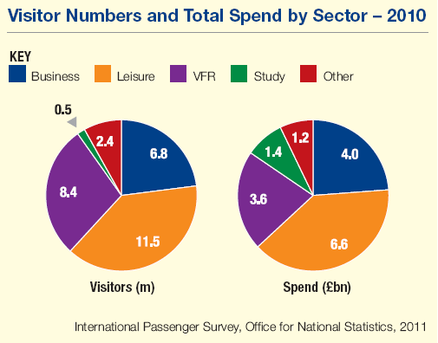

Total expenditure by the international students for all course types in United Kingdom, from English language to all kinds of doctoral degrees, had been valued to be approximately £14 billion, and has the potential of growing to £21bn by 2020 (Department for Business, Innovation and Skills, 2011). The country’s tourism industry employed more than 2.66mn individuals in 2009. The tourism sector is the country’s 3rd largest employer, employing around 9 percent of the total employed people of UK. Its 249000 businesses account for 10 percent of the total businesses in the country (Office for National Statistics, 2012b). The tourism sector proves to be a noteworthy incubator for UK’s entrepreneurs as notwithstanding the economic slump, the sector saw 21,580 start-ups in 2009. Besides being an important employer, the tourism sector employs many young people & school leavers with 44% of the people employed being less than 30 years of age in comparison to national average of 24 percent, while the turnover rate for the sector has drastically reduced to 23 percent (People 1st, 2011). With every £50,000 worth increase in the tourism revenue a new full time worth tourism job is created and sustained (VisitBritain, 2002). According to BTA (2001) for every 1 percent escalation in the cost to visit UK, the country’s tourism earnings decrease by 1.3 percent. Travel expenditure in 2010 by foreigners visiting United Kingdom accounted for 12.3 percent of the country’s service sector exports as well as 4.8 percent of the total exports by UK (HM Treasury, 2011). The report also states that in UK tourism is the 6th largest earner, after Chemicals, Financial Services, Intermediate Manufactured Goods, Capital Goods, and Transportation.

TOURISM PLANNING
Planning relates to setting of and meeting the desired objectives. Although there have been numerous approaches developed regarding general planning, for example, boosterism, collaborative, bottom-up, integrated, interactive etc, a tourism literature review shows that very few authors were concerned towards tourism planning. This is due to the reason that these plans are mostly developed by the consultancy firms which rarely divulge or publish their secrets (Akehurst, 1998). Only during the last twenty years few authors such as Tosun & Jenkins (1998); Wilkinson (1997); Gunn (1994); Inskeep (1991); Timothy (1999) have shown concern towards the tourism planning aspects. Likewise, few approaches were proposed for tourism planning implementation, mainly, systematic approaches or numerous product/market options.
Early research on tourism such as by Alexander (1953); Ogilvie (1933) on the tourism planning outcomes was primarily restricted to measuring economic effects for the destination areas, because of the easiness with which the economic impacts could be measured, in comparison to social & environmental impacts (Archer & Cooper, 1998; Mathieson & Wall, 1982; Kontogeorgopoulos, 1998) as well as the local government’s attempts for optimising economic benefits (Stynes & Stewart, 1993; Allen et al., 1988). Hawkins (1992) contends that for maximizing economic benefits most governments allowed private sector firms for taking key decisions regarding development of tourism in an unplanned & unrestricted way. Nevertheless, the emphasis of tourism planning & private sector was obviously oriented mainly toward economic gains in the short-term, by constructing facilities that would act as an attraction for the foreign visitors. Seth (1985); Jenkins (1994) believe that because of the above, hardly any attention was being given to the host community’s socio-cultural effects and the environmental difficulties for the receiving destinations, that in a long-term, might dwarf the benefits. Therefore, this unrestrained & unplanned tourism development diminished a lot of destination’s image to often an extent that these destinations then attract only the mass low-spending tourism. Consequently, serious environmental & socio-economic problems emerged. As tourism activity depends on socio-cultural & environmental resources protection for tourist attraction, planning activity assumes a major role for a destination’s success.

The components of tourism planning process:
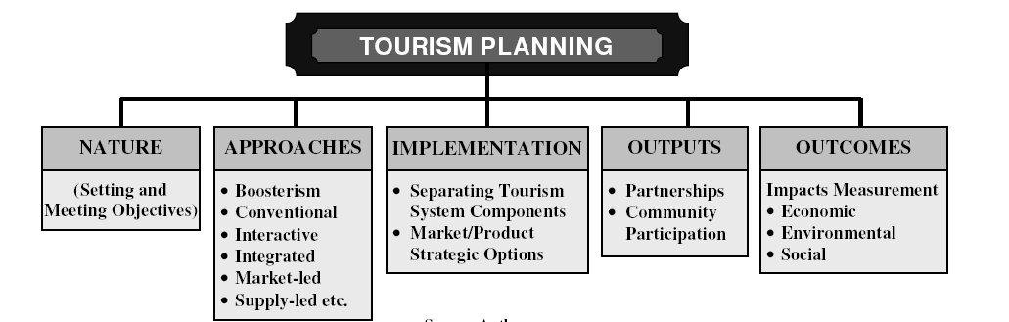

The Nature of Planning
Planning is a vital activity for achieving the tourism development goals. Planning refers to anticipation & regulation change in the system for promoting orderly development in order to increase economic, social as well as environmental benefits by the process of development (Murphy, 1985). He believes that for doing this, planning translates into a structured operation sequence, designed for leading to achieve either an individual goal or for balancing between numerous goals.
Tourism planning was first defined by Gunn (1979) as a destination area development tool, and can be viewed as a method to assess the requirements of a destination which receives tourist. The focus of tourism planning is chiefly to generate employment & income, and ensuring traveller satisfaction & resource conservation (Gunn, 1994). Specifically, the under developed destinations through planning could obtain guidelines for greater tourism development. WTO (1994) believes that meanwhile, for developed nations, planning could be used for revitalizing the tourism sector as well as maintaining its viability for future.
Every process of development begins with local/central government recognition, after consulting with public & private sector, that it is a desirable option of development for expanding tourism in an extremely planned manner. For successfully designing the development plan for tourism, it is vital to clearly understand the objectives of development that must be achieved at a local, regional or national level. These objectives’ nature depends on the regional, local or national preferences rooted to the nation’s scale of socio-cultural, political, economic and environmental values, and also its development stage. Development objectives could be political, socio-cultural, environmental, and economic. Alternatively, objectives could represent a mix of political, environmental, sociocultural and economic goals, though they must consider the needs and desires of local communities for retaining its support continuously.
Unfortunately, according to WTO (1994) often the objectives conflict with each other and thus cannot be achieved realistically. For instance, if the government’s main objectives are of achieving spatial tourism activity distribution of and increase expenditure by tourists, these objectives witness opposition, because for increasing tourism expenditure first the tourists need to be attracted towards the capital of the country or its largest cities, where more spending alternatives exist, like in shopping and entertainment. Thus, it is proposed that objectives’ choice must be limited towards those aspirations that the industry has the capability of meeting or seem most suitable to serve (Haywood, 1988).

Planning Approaches
A major tourism planning tradition, or debated as a non-planning form by as Hall (2000) is boosterism. Getz (1987); Hall (1991) and Dredge (1999) as per boosterism approach, tourism benefits a destination where its environmental objects & inhabitants are promoted in the form of assets for stimulating market interest & increasing economic benefits as well as reducing development barriers. Local residents generally are not a part of the planning process as well as the region’s carrying capacity is not provided adequate consideration (Page, 1995). Accordingly, Getz (1987) contends that this approach doesn’t offer a sustainable development solution and is mostly practiced by politicians only, who pragmatically or philosophically hold the belief that the economic growth must always be promoted besides by others that would financially gain by tourism. Tourism evolution fetches numerous problems for the local communities, such as overcrowding, superstructure, traffic congestion and a weakening socio-cultural. A lot of these difficulties according to Edgell (1990) could be ascribed to the laissez-faire policies of tourism and inadequate planning, and Mill and Morrison (1985) further add that although few destinations benefited through tourism development with no ‘conscious’ planning, most are suffering because of inattentive planning.
Baud-Bovy (1982) argues that although maximum nations have prepared the plans of tourism development, a lot of them are never implemented, while others are only partly implemented. This could be because of conventional planning, that is, it has mostly been concerned with only a plan which is too vague, tries to encompass everything, reactive, divorced from budgets, sporadic and unnecessary data producing (Gunn, 1988).
Gunn (1994) has proposed interactive planning instead of conventional planning while collaborative planning has been proposed by Bramwell & Sharman (1999) and Timothy (1999) suggested participatory & co-operative planning, all aiming along similar lines that means, incorporating opinions & desires of local community members into the planning process. Hence, interactive planning suggests top-down, along with bottom-up input, to better implement the plans. Braddon (1982) on the other hand, suggested that the tourism planning must be market oriented, offering the consumers (the tourists) right product. A total market based approach that offers attractions services and facilities, the tourist market might demand may lead to environmental degradation as well as loss of integrity of socio-cultural of that tourist area, though it might provide economic benefits in the short term (Inskeep, 1991). Hence, he suggests that for avoiding such a situation a more suitable approach would be the product led approach. Baud-Bovy & Lawson (1977) have also mentioned this approach along with their PALSOP (product analysis sequence for outdoor leisure planning) in which emphasis has been given on product (that is, the supply), which indicates the requirement for ‘supply-led’ approach towards tourism planning. Supply-led approach means only those kinds of attractions, services or facilities are provided which the area considers can be best integrated with least impacts on local development society and promotion is done for attracting only those travelers who find a product of importance to them (Inskeep, 1991). Agreeing to the above Gunn (1994) and Mill (1990) state only an integrated plan has the ability of reassuring communities that development results would be appropriate.
According to Hall (2000); Gunn (1994); Baud-Bovy (1982) and de Kadt (1979) tourism planners must learn from the mistakes committed in another place and realize that planning process is a continuous process and not a static process which requires integration of exogenous changes as well as additional information. Hence, according to Atach-Rosch (1984) and Choy (1991) tourism planning must be flexible as well as adaptable for coping with swiftly changing situations and conditions faced by the community. Nevertheless, Butler (1993) argues that most decision makers are mostly located far off from the current destination which is under development signifying they might be unconcerned or unaware regarding any costs arising due to tourism development.
Planning is like predicting and necessitates a couple of estimated future perception (Gunn, 1988). Lack of planning which doesn’t predict a future could result in grave inefficiencies and malfunctions. Therefore, it was proposed that planning must incorporate strategic thinking (Wilkinson, 1997). Tourism planning according to WTO (1993) could take place at numerous levels which range from macro level (i.e. national & regional) to the several micro local levels of planning. It has also been suggested that plans prepared for one level must be exclusively focused towards that level, though it must be guaranteed that it fits into other level’s context as planning at each level could have an influence on planning at some another level (Pearce, 1995). Tosun and Jenkins (1998) summed up, the tourism development planning evolution of in the form of five:
- Unplanned era of tourism development: tourism planning was unpopular, uncommon and was an unwanted notion, and hence tourism emerged as unplanned activity.
- Beginning of partially supply-oriented tourism stage of planning: this stage witnessed creation of the basic infrastructure, like restaurants, hotels, transportation and so on.
- Entirely supply-oriented tourism era: this stage involves planning which is directed at creating facilities which fulfill increased demands of tourism, although ignoring most resulting issues.
- Market or demand-oriented era: it involves tourism planning which is focused largely on greater tourist numbers and means of satisfying them.
- Contemporary planning approach of tourism development planning stage: after tourist arrival numbers increased the planners focused on environmental, economic and socio-cultural problems.

Implementation of Planning
These tools and techniques for tourism planning implementation:
- A systems approach to tourism planning
Pearce (1989); Liu (1994) suggest that to better understand the relationships or linkages within tourism system, it is important to separate its components for reducing its complexity as well as for identifying the component’s relationships. Tosun & Jenkins (1998) believe this approach holds the benefit of adopting a much broader view in place of being isolated & myopic and. Consequently, several researchers such as Gunn (1988); Mill and Morrison (1985); Inskeep (1991); Page (1995); WTO (1998); Pearce (1989) and Harssel (1994) adopted a systematic approach towards tourism planning.
Three tourism system environments were identified by Liu (1994):
- The internal environment: this includes planning, marketing, policy, financial, human and organizational variables.
- The operating environment: comprises of tourists (foreign & domestic), the input suppliers (capital, land, labour, materials, power, technology, etc.), other industry’s competition (such as, leisure) and competition from various other destinations.
- The macro-environment: Since planning according to Tosun & Jenkins (1998) is a multi-faceted phenomenon, the system approach proposes that effective tourism planning seems vital for incorporating economic, political, socio-cultural, geographical and technological variables.

The three environments of tourism system
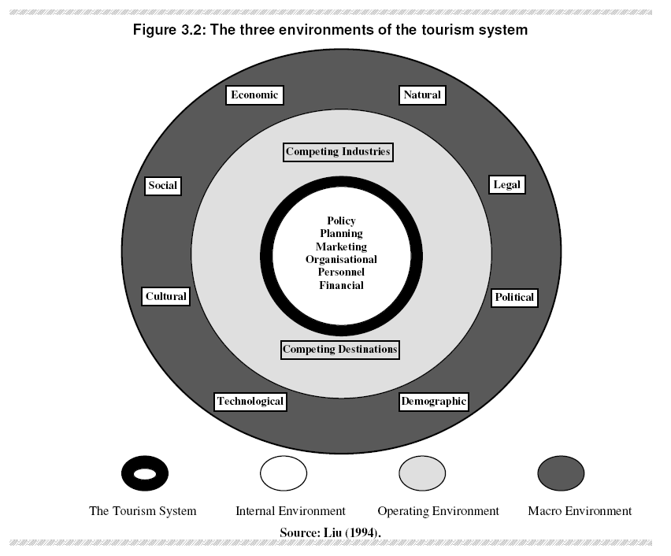
- Market/product strategic options
General planning practices empirical studies have provides various popular tools & techniques of planning for fulfilling development objectives by use of several market/product strategic options.
Gilbert (1990); Porter (1980); Henderson (1979); Ansoff (1965) proposed similar alternatives regarding how an organization (or destination) could achieve market leadership by competitive advantage. A differentiation/leadership started has been suggested by many researchers for attaining this competitive edge. Differentiation has been considered by Ansoff (1965) as a new product being served to new market while Henderson (1979) advocates differentiation to be through products having high market shares in rapid growing markets(that is, star product). It has been suggested by Gilbert (1990) that a country should move towards creating a status area position from the commodity position, by development of benefits of tourism product and leadership was viewed by Porter (1980) from 3 angles namely differentiation, low-cost and focus strategy.

Partnerships in Tourism Planning
Tourism industry has numerous examples regarding highly effective partnership arrangements leading to tourism planning & development’s success. According to Sharpley & Sharpley (1997) public sector generally is concerned relating to the service provisions, land-use conflicts resolutions and the formation as well as implementation of the policies of development, while private sector chiefly is concerned relating to profits, hence private & public sector partnerships on numerous issues could benefit destinations.
Tosun (2000); Timothy (1999) and McIntosh & Goeldner (1986) were of the view that community involvement towards tourism could be seen from two viewpoints, firstly, in the tourism development benefit and secondly, in the process of decision-making. Greater community involvement could result in more wastage of time to reach decisions and thus it is regarded as unnecessary as well as cumbersome. The costs of such policies are not just financial but even include executive burdens, like possible power dilution, the dearth of time for interacting with citizens, patience of educating others, the tolerance of being educated by others, the determination of improving negotiation skills, courage of risking some damage to control on internal industry matters, and, eventually, the risk of failure as well as the discomfort of negative publicity (Haywood, 1988).

Measuring Tourism Impacts
The planning objective is to assess whether the goals have been achieved by measuring the environmental, social and economic impacts.
Economic measures
Tourism studies propose that development chiefly is associated with prosperity of the economy. Hence, the maximum used tourism research measures concern economic impacts. Economic potential of tourism could be assumed as gross increase of people’s income located in a specific area, generally measured using monetary terms, as well as the income changes that might occur in tourism activity’s absence (Frechtling, 1994a). Measures related to direct tourism benefits according to Frechtling (1994b) include business receipts, labour earnings, tax revenue and number of jobs. The tourism economic researches focus on measuring tourism’s economic benefits to communities. Numerous work (such as Ruiz (1985); Liu et al. (1984); Jackson (1986); Milne (1987); Archer & Fletcher (1988); Khan et al. (1990); Archer (1995)) are based on multiplier analysis concept that is based on the fact that the impact of tourism is not constrained in the initial goods & services consumption but also is due to calculation of direct as well as secondary effects shaped due to additional expenditure on tourism within an economy.
Environmental measures
In an effort to remove environmental costs, most nations have included EIA (Environmental Impact Assessment) in their legislation for every project, including tourism. According to ODA (1992); Green and Hunter (1993) its aim is for predicting the environmental effects of a planned development activity, as well as for ensuring that the probable risks are foreknown and required measures for avoiding, mitigating or compensating for environmental hurt are identified.
Social measures
The socio-cultural tourism impacts are most challenging to be measured and quantified, as they often are extremely subjective & qualitative in nature Cooper et al. (1998, p.180).

Planning For Tourism: UK

London Borough of Greenwich is one of the local authorities of UK which has actively worked by using the planning system for underpinning tourism development in its area. Greenwich, located in south-east of London, also is home to Maritime Greenwich World Heritage Site which receives more than 8mn visitors annually. Tourism in Greenwich directly employs nearly 6,000 individuals locally and generates nearly £1/3 bn annually for the country’s economy (DCLG, 2006). The authority has recognised significance of tourism for the area’s well-being and places tourism at the core of its determined regeneration program. Close working along with private sector firms, which included attractions, developers and operators have underpinned the approach adopted by Greenwich.
Planning Department’s work has been critical to the success. The work done by the authority included:
- Committing specific development plan portions towards tourism as well as its promotion
- consulting with the stakeholders regarding planning applications as well as involvement with other partners for preparing planning briefs;
- Preparation of hotel strategies which actively promote sites to the hotel developers & operators. This has resulted in creation of 2 new hotels and also increased visitor expenditure in local economy;
- Lobbying for public transport improvements with partners in private sector. This has also helped in securing investment in services of underground, light rail, and river transport;
- Active engagement along with bed & breakfast establishments owners and small hoteliers for giving advice regarding issues of planning;
- Obtaining contributions for tourism initiatives by s106 agreements, as well as voluntary contributions and aids for marketing purposes; and
- Working with operators & developers for securing business opportunities and local employment.

SUSTAINABLE TOURISM
Sustainable tourism development according to WTO (1996) meets the requirements of the present-day tourists & host regions besides protecting as well as enhancing the future opportunities. It is envisioned as resulting in management of each and every resource in a manner that economic, aesthetic and social needs are fulfilled, while simultaneously maintaining integrity of cultural, vital ecological procedures, life support systems and the biological diversity.

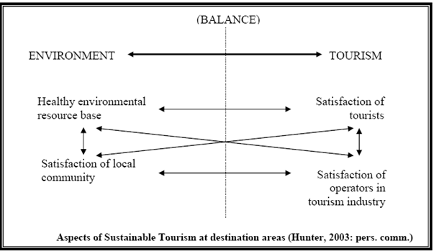

The figure above illustrates the relationships among different sustainable tourism aspects, elucidating one viewpoint on the ‘balancing act’ of tourism-environment required for achieving sustainability. The sustainable tourism goals relate to diverse tourism carrying capacity kinds. The illustration above principally indicates that no individual aspect ought to be allowed for dominating tourism decision-taking and policy-making.
Good designs are also vital to achieve sustainable development and would contribute positively to make a better place for people. Careful building design could also make these buildings more sustainable through reduced carbon emissions because of construction. Energy conservation processes and use of renewable technologies like solar and wind power could reduce energy requirements of buildings as well as other operating costs, while enhancing their sustainability. A vital contribution towards sustainability could also be achieved by selecting and using suitable materials. Materials sourced locally sources would have lesser embodied energy (that is lower amount of fossil fuels would have been consumed for their transportation and perhaps their processing). Locally-sourced items would also create local jobs, thereby diversifying as well as strengthening local economy, besides making final development more likely of fitting well with local surroundings and environment. Re-using buildings which are now redundant further enhances overall new development’s sustainability. Often this also has the benefit of maintaining significant & historic buildings as well as providing continuity to townscape & landscape.

CONCLUSION
Tourism is a practice which involves travelling to a place outside an individual’s normal environment for certain period of time for leisure, business etc. Tourism plays a key role in United Kingdom. Tourism industry of UK is amongst the keys to rebuild the country’s economy and to generate employment, especially in places it is extremely needed like the rural communities. The tourism sector is the country’s 3rd largest employer, employing around 9 percent of the total employed people. UK tourism is the 6th largest earner, after Chemicals, Financial Services, Intermediate Manufactured Goods, Capital Goods, and Transportation. Planning relates to setting of and meeting the desired objectives. As tourism activity depends on socio-cultural & environmental resources protection for tourist attraction, planning activity assumes a major role for a destination’s success. Tourism planning is defined as a destination area development tool, and can be viewed as a method to assess the requirements of a destination which receives tourist. For developed nations, planning could be used for revitalizing the tourism sector as well as maintaining its viability for future. For successfully designing the development plan for tourism, it is vital to clearly understand the objectives of development that must be achieved at a local, regional or national level. Often the objectives conflict with each other and thus cannot be achieved realistically. Tourism planning could take place at numerous levels which range from macro level (i.e. national & regional) to the several micro local levels of planning. Three tourism system environments identified are the internal environment, the operating environment and the macro-environment. Public sector generally is concerned relating to the service provisions, land-use conflicts resolutions and the formation as well as implementation of the policies of development, while private sector chiefly is concerned relating to profits, hence private & public sector partnerships on numerous issues could benefit destinations. The planning objective is to assess whether the goals have been achieved by measuring the environmental, social and economic impacts. Tourism in Greenwich directly employs nearly 6,000 individuals locally and generates nearly £1/3 bn annually for the country’s economy. Sustainable tourism development meets the requirements of the present-day tourists & host regions besides protecting as well as enhancing the future opportunities. Energy conservation processes and use of renewable technologies like solar and wind power could reduce energy requirements of buildings as well as other operating costs, while enhancing their sustainability.

REFERENCES
Akehurst, G. (1998) “Tourism planning and implementation in the Polish city of Kalisz”, In: Laws, E., Faulkner, B. and Moscardo, G. (eds), Embracing and Managing Change in Tourism: International Case Studies, Routledge, London, pp.49-69.
Alexander, L.M. (1953) “The impact of tourism on the economy of Cape Cod”, Economic Geography, Massachusetts, 29, pp. 320-326.
Allen, L.R., Long, P.T., Perdue, R.R. and Kieselbach, S. (1988) “The impact of tourism development on residents’ perceptions of community life”, Journal of Travel Research, 27(1), pp.16-21.
Ansoff, H. (1965) Corporate Strategy, Penguin, Harmondsworth.
Archer, B.H. (1995) “Importance of tourism for the economy of Bermuda”, Annals of Tourism Research, 22(4), pp. 918-930.
Archer, B.H. and Fletcher, J. (1988) “The tourist multiplier”, Teoros, 7, November, pp. 6-10.
Atach-Rosch, I. (1984) Public Planning for Tourism: A General Method for Establishing Economic, Environmental, Social and Administrative Criteria, PhD thesis, University of Washington, Washington.
Baud-Bovy, M. (1982) “New concepts in planning for tourism and recreation”, Tourism Management. 3(4), pp. 308-313.
Baud-Bovy, M. and Lawson, F. (1977) Tourism and Recreation: A Handbook of Physical Planning, CBI, Boston.
Braddon, C.J.H. (1982) British Issues Paper: Approaches to Tourism Planning Abroad, British Tourism Authority: London.
Bramwell, B. and Sharman, A. (1999) “Collaboration in local tourism policymaking”, Annals of Tourism Research, 26(2), pp. 392-415.
Butler, R.W. (1993) “Pre- and post-impact assessment of tourism development”, In: Pearce, D.G. and Butler, R.W. (eds), Tourism Research: Critiques and Challenges, Routledge, London, pp. 135-155.
Choy, D.J.L. (1991) “Tourism planning: the case for ‘market failure”, Tourism Management. 12(4), pp. 26-31.
Cooper, C., Fletcher, J., Gilbert, D. Shepherd, R. and Wanhill, S. (1998) Tourism Principles and Practices. 2nd ed. Pitman, London.
Cooper, C., Fletcher, J., Gilbert, D. Shepherd, R. and Wanhill, S. (1998) Tourism Principles and Practices. 2nd ed. Pitman, London.
DCLG (2006) “Good Practice Guide on Planning for Tourism”, Department for Communities and Local Government, London.
de Kadt, E. (1979) Tourism: Passport to Development? (ed), Oxford University Press, Oxford.
Deloitte (2010) “The Economic Contribution of the Visitor Economy– UK and the Nations”, Deloitte.
Department for Business, Innovation and Skills (2011) “Estimating the Value to the UK of Education Exports”, Department for Business, Innovation and Skills.
Dredge, D. (1999) “Destination place planning and design”, Annals of Tourism Research, 26(4), pp. 772-791.
Edgell, D.L. (1990) International Tourism Policy, Van Nostrand Reinhold, New York.
Frechtling, D. (1994a) Assessing the economic impact of travel and tourism - Introduction to travel impact estimation, In: Ritchie J.R.B. and Goeldner, C.R. (eds), Travel, Tourism and Hospitality Research. 2nd ed. New York: Wiley, pp.359-365.
Frechtling, D. (1994b) Assessing the economic impact of travel and tourism – Measuring economic benefits, In: Ritchie J.R.B. and Goeldner, C.R. (eds), Travel, Tourism and Hospitality Research. 2nd ed. New York: Wiley, pp.367-391.
Getz, D. (1987) “Tourism planning and research: traditions, models and futures”, Paper Presented at The Australian Travel Research Workshop, 5-6 November, Bunbury, Western Australia.
Gilbert, D. (1990) “Strategic marketing planning for national tourism”, Tourist Review, 1, pp. 18-27.
Green, H. and Hunter, C. (1993) “The environmental impact assessment of tourism development”, In: Johnson, P. and Thomas, B. (eds). Perspectives on Tourism Policy. London: Mansell, pp.29-48.
Gunn, C.A. (1979) Tourism Planning, Russack and Company, New York.
Gunn, C.A. (1988) Tourism Planning. 2nd ed.,Taylor & Frances, New York.
Gunn, C.A. (1994) Tourism Planning: Basics, Concepts, Cases. 3rd ed., Taylor & Frances, Washington.
Hall, C.M. (1991) Tourism in Australia: Impacts, Planning and Development, Longman, Melbourne.
Hall, C.M. (2000) Tourism Planning: Policies, Processes and Relationships, Prentice Hall, Essex.
Harssel, J.V. (1994) Tourism: An Exploration, Prentice Hall, Englewood Cliffs, NJ.
Hawkins, R. (1992) “The Planning and Management of Tourism in Europe: Case Studies of Planning, Management and Control in the Coastal Zone”, PhD Thesis, Bournemouth University, Bournemouth.
Haywood, K.M. (1988) “Responsible and responsive tourism planning in the community”, Tourism Management. 9(2), pp. 105-116.
Henderson, B.D. (1979) Henderson on Corporate Strategy, Abt Books, Cambridge.
HM Treasury (2011) “The Pink Book”, HM Treasury.
Inskeep, E. (1991) Tourism Planning: An Integrated and Sustainable Development Approach, Van Nostrand Reinhold, New York.
Jackson, M.J. (1986) Economic Impact Studies: The Methodology Applied to Tourism, Bristol Polytechnic, Bristol.
Jenkins, C.L. (1994) “Tourism in developing countries: the privatisation issue”, In: Seaton, A.V. (ed), Tourism: The State of Art, Wiley, Chichester, pp.3-9.
Khan, H., Seng, C. F. and Cheong, W. K. (1990) “Tourism multiplier effects on Singapore”, Annals of Tourism Research. 17(3), pp. 408-418.
Kontogeorgopoulos, N. (1998) “Accommodation employment patterns and opportunities”, Annals of Tourism Research, 25(2), pp. 314-339.
Liu, Z. H. (1994) “Tourism development - A system analysis”, In: Seaton, A.V. (ed), Tourism: The State of Art. Wiley, Chichester, pp. 20-30.
Mathieson, A. and Wall, G. (1982) Tourism Economic, Physical and Social Impacts, Longman, London.
McIntosh, R.W. and Goeldner, G.R. (1986) Tourism: Principles, Practices, Philosophies, 5th ed., Wiley, New York.
Mill, R.C. (1990) Tourism: The International Business, Prentice-Hall, New Jersey.
Mill, R.C. and Morrison, A.M. (1985) The Tourism System: An Introductory Text, Prentice-Hall, New Jersey.
Milne, S. (1987) “Differentiation multipliers”, Annals of Tourism Research, 14 (3), pp. 498-515.
Murphy, P.E. (1985) Tourism: A Community Approach, Methuen, London.
ODA (1992) Manual of Environmental Appraisal, Overseas Development Administration, London.
Office for National Statistics (2012a) “International Passenger Survey”, Office for National Statistics.
Office for National Statistics (2012b) “Supply Side of Tourism Report”, Office for National Statistics.
Ogilvie, F.W. (1933) The Tourism Movement, P.S. King.
Page, S. (1995) Urban Tourism, Routledge, London.
Pearce, D.G. (1989) Tourist Development. 2nd ed., Longman, New York.
Pearce, D.G. (1995) “Planning for tourism in the 1990s: An integrated, dynamic, multiscale approach”, In: Butler, R.W. and Pearce, D.G. (eds). Change in Tourism: People, Places, Processes, Routledge, London, pp. 229-244.
People 1st (2011) “State of the Nation Report”, People 1st.
Porter, M.E. (1980) Competitive Strategies: Techniques for Analysing Industries and Competitors, Free Press, New York.
Ruiz, A.L. (1985) “Tourism and the economy of Puerto Rico: an input-output approach”, Tourism Management. 6(1), pp. 61-65.
Seth, P.N. (1985) Successful Tourism Management, Stirling, New Delhi.
Sharpley, R. and Sharpley, J. (1997) Rural Tourism: An Introduction, Thomson, London.
Simmonds, B. (2012) “UK Tourism Statistics 2012”, Tourism Alliance, London, UK.
Stynes, D.J. and Stewart, S.I. (1993) “Tourism development and recreation: Some findings from a case study”, Journal of Park and Recreation Administration, 11, pp. 30-44.
Timothy, D.J. (1999) “Participatory planning: A view of tourism in Indonesia”, Annals of Tourism Research, 26(2), pp. 371-391.
Tosun, C. (2000) “Limits to community participation in the tourism development process in developing countries”, Tourism Management, 21(3), pp. 413-633.
Tosun, C. and Jenkins, C.L. (1998) “The evolution of tourism planning in third world countries: A critique”, Progress in Tourism and Hospitality Research, 4(2), pp.101-114.
UNWTO (1995) “Technical Manual Collection of Tourism Expenditure Statistics World Tourism Organization”, UNWTO, p. 14.
UNWTO (2011) UN World Tourism Organization.
VisitBritain (2002) “Employment Generated by Tourism in Britain”, VisitBritain.
Wilkinson, P.F. (1997) Tourism Policy and Planning: Case Studies from the Commonwealth Caribbean, Cognizant Communication Corporation, New York.
WTO (1993) Sustainable Tourism Development: Guide for Local Planners, World Tourism Organisation, Madrid.
WTO (1994) National and Regional Tourism Planning: Methodologies and Case Studies, Routledge, London.
WTO (1996) “What tourism managers need to know: a practical guide to the development and use of indicators of sustainable tourism”, Prepared for WTO by Manning, T., Clifford, G., Docherty, D. and Ernst, M. Consulting and Audit Canada: Ottawa.
WTO (1998) Guide for Local Authorities on Developing Sustainable Tourism, World Tourism Organisation, Madrid.

